The Dream Keeper

Text from "The Dream Keeper" by Langston Hughes (1902-1967)
Music by Rollo A. Dilworth (b. 1970)

Background

"Langston Hughes (1902-1967) is considered one of the most prolific and powerful African-American writers in 20th Century American literature. His verses often reflect the experiences that spoke directly to the societal issues of his time, including politics, religion and racism.

""The Dream Keeper" depicts the legend of a fictitious character whose role is to protect the dreams of those who are willing to hand over their deepest passions and heartfelt desires to him. The repetition found in the opening vocal phrases (mm. 4-7) represents the voices of the dreamers who call upon the Dream Keeper for assistance. Subsequent passages that summon the Dream Keeper (mm. 17-18; 28-29) can be repeated once (as written) or repeated multiple times if the conductor chooses to have individual students verbalize their dreams as the chorus continues to call upon the Dream Keeper.

"The stylistic setting of the poem is rooted in blues and jazz. The optional acoustic bass and conga parts will assist in creating the desired effect.

""The Dream Keeper" can be performed as a single selection or as a part of a multi-movement work for treble voices, piano and optional chamber ensemble entitled Trilogy of Dreams. The order of selections (movements) is as follows:

No. 1 - "The Dream Keeper" (2-part)
No. 2 – "Dreams"
No. 3 – "I Dream a World"

This three-movement song cycle is unified through text and tonality. The texts from all three Langston Hughes poems express a collective hope in the power of dreams. The tonality of the trilogy goes full circle, moving from D minor to E minor, to F major, to D-flat major, and finally to D major. What appears to be tonal uncertainty and a mood of modest hope in the beginning of the cycle is replaced by tonal stability and celebration in the final bars of the third movement."

Program Notes
The Dream Keeper by Rollo Dilworth is part of a trilogy (Trilogy of Dreams) settings of poetry by Langston Hughes. In the words of Dilworth, this particular poem
depicts the legend of a fictitious character whose role is to protect the dreams of those who are willing to hand over their deepest passions and heartfelt desires to him. The repetition found in the opening vocal phrases … represents the voices of the dreamers who call upon the Dream Keeper for assistance.

Recordings

Strathmore Children’s Choir: https://youtu.be/_IXEZQMHVJs
Vocal Arts Young Artists: https://youtu.be/efi8Kq6mimE - really a great recording.

Analysis
Key: D minor
Meter: 4/4
Form: A A’ A”

Ms. 1-3 | Ms. 4-7 | Ms. 8-16 | Ms. 17-18 | Ms. 19-27
Key of d minor: Piano introduction | 1st statement of Dream Keeper ostinato (example 1) | 1st statement of melody, all parts in unison. | Re-statement of dream keeper ostinato (2 x) | 2nd statement of melody, melody in alto line; soprano line often doubles, sometimes adds a descant.
Ms. 28-29 | Ms. 30-39 | Ms. 40-42
Re-statement of dream keeper ostinato (2 x) | 3rd statement of melody in strict canon: upper voice begins the canon, and lower voice joins 1 measure later. | Coda: uses first measure of ostinato pattern, and voices sustain on a major second for remaining two measures.

Example 1
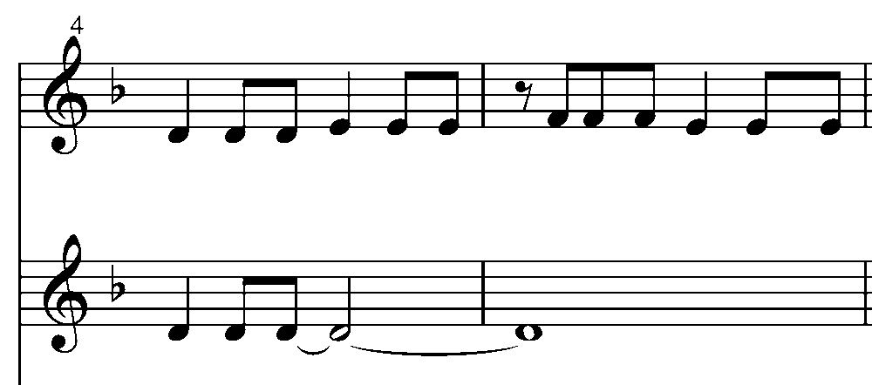

Rollo Dilworth, The Dream Keeper; Hal Leonard, 2006, p. 2.
Rollo Dilworth, The Dream Keeper; Hal Leonard, 2006, p. 2.

